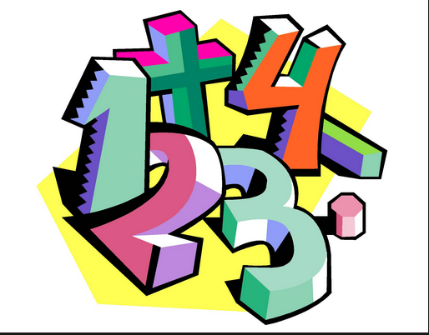

Name _____________ Due: ________

I Played a Math Game at Home!

I played ______________________
(name of math game)

with _________________________ on
(name of person)

____________________________.
(date)
I played the game on the computer.
I liked playing the game.
I did not like playing the game because _______________________________

