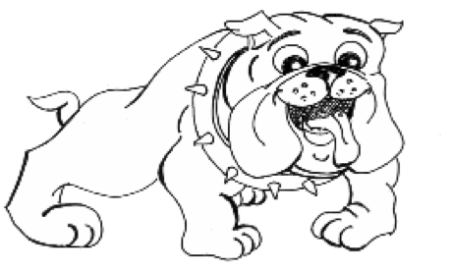
Bulldog Challenge Spelling Homework Options
1. Use magnetic letters, ABC cards, ABC cereal or play-dough to spell each word.

2. RAINBOW WORDS: Write each word THREE times each. Each time, use something different (colored pencils, crayons or markers).

3. Find each word (or letters to spell each word) in a magazine or newspaper. Cut the letters and/or words, glue or tape them to a piece of paper.

4. Print your words with your fingers FIVE or more times in flour, salt, sugar or shaving cream.

5. Use colored chalk to write your words on the sidewalk.

6. Write your words in a list. Then write TWO or more words that rhyme with each spelling word next to them.

7. Write the spelling words THREE times each. Circle the vowels and underline consonants.

8. Write the words in a list. Then write a word next to each spelling word that begins with the same letter as your word. (Example: we-will)

9. Draw a picture. Write ONE or TWO sentences about your picture. Use at least THREE of your spelling words in the sentence(s).

10. LOOK. COVER. WRITE. CHECK. Look at each word. Cover the word. Write the word from memory. Check what you have written. If the word is misspelled, write the word correctly.

11. Take a practice test. Review any missed words.

12. Put the words in a crossword puzzle format. (Example and paper are attached.)

13. Write the words two times on separate index cards or slips of paper. Play concentration. When you make a match, be sure to say and spell each word. (Directions are attached.)

14. Write a sentence for each word.

15. Soccer Spelling (Directions and game board were included in your Challenge Homework Folder. If you need more game boards, just ask me.)

16. Tic-Tac-Toe (Directions and game board were included in your Challenge Homework Folder. If you need more game boards, just ask me.)

17. Visit Spellingcity.com/brossB. Select: The weekly story. Select: Spelling
Test, Teach Me, or Play a Game.

18. Type your words on the computer.

19. Write the words in ABC order.

20. Create your own way to practice the words.

REMEMBER, IF YOU CHOOSE AN OPTION THAT DOESN'T HAVE A WRITTEN ASSIGNMENT, PLEASE COMPLETE THE CHALLENGE SPELLING WOR HOMEWORK OPTION FORM (ON THE NEXT PAGE) TO LET ME KNOW HOW YOU PRACTICED THE WORDS THIS WEEK.

Name____________________

Bulldog Spelling Challenge Homework Options

If the option you chose did not have a writing assignment, please tell me which option(s) you used to practice your words.

For this week’s spelling homework, I

1. _______________________________________________

______________________________________________

2. ______________________________________________

______________________________________________

3. ______________________________________________

______________________________________________

